quebec-1-10v-pir

Introduction
There are two variants of this product one is for prototyping which has the USB to serial chip and can be flash using the USB. The other one is production one that needs tag-connect and programmer. (check, Figs 1,2 and 3)
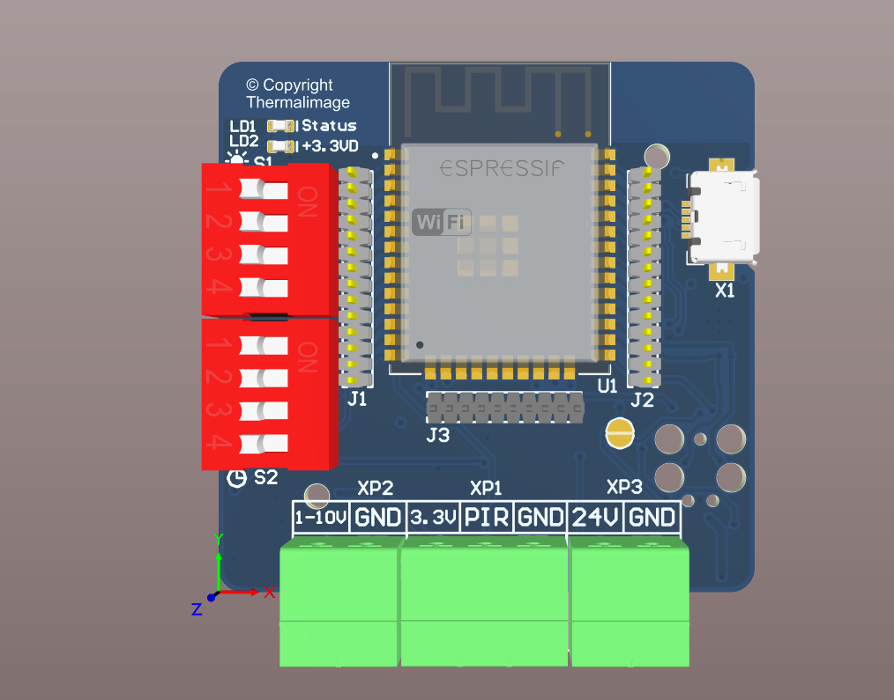
Figure 1: Top view prototype and Production.
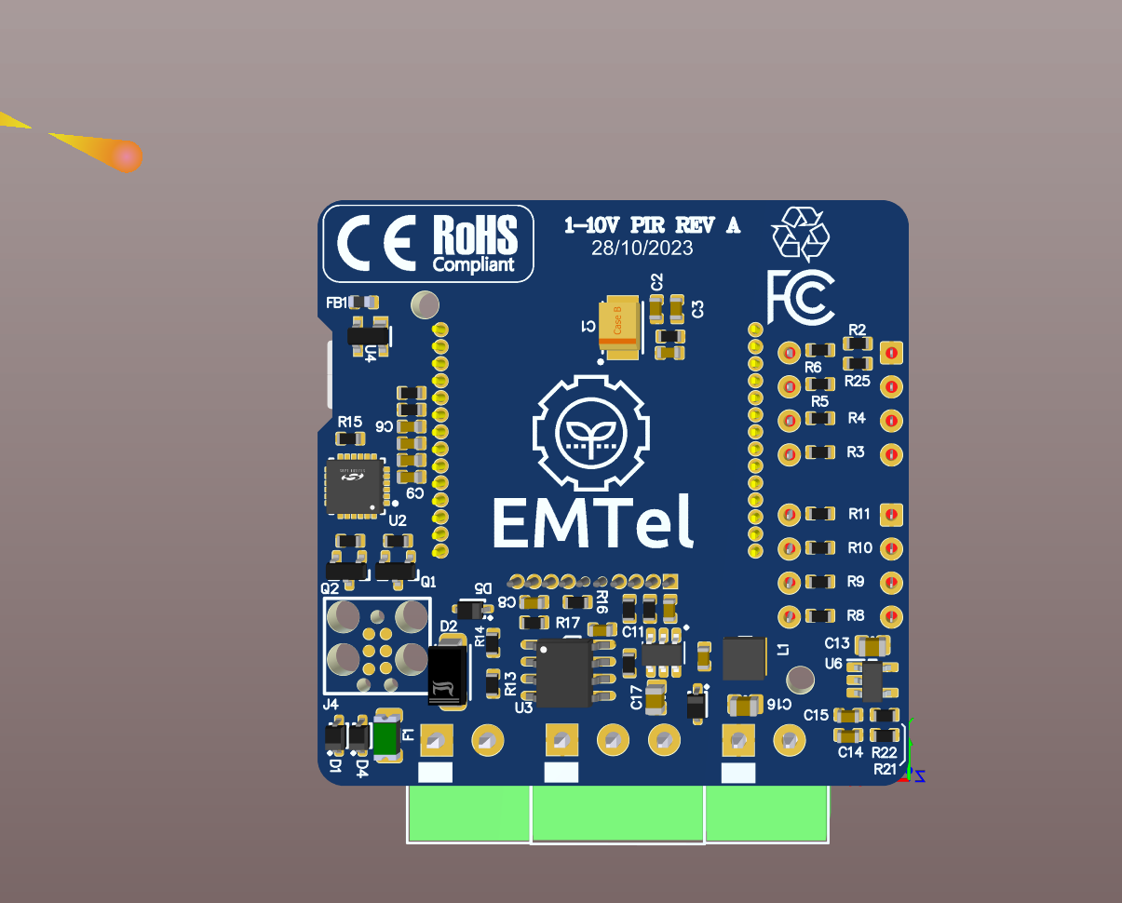
Figure 2: prototype bottom view.

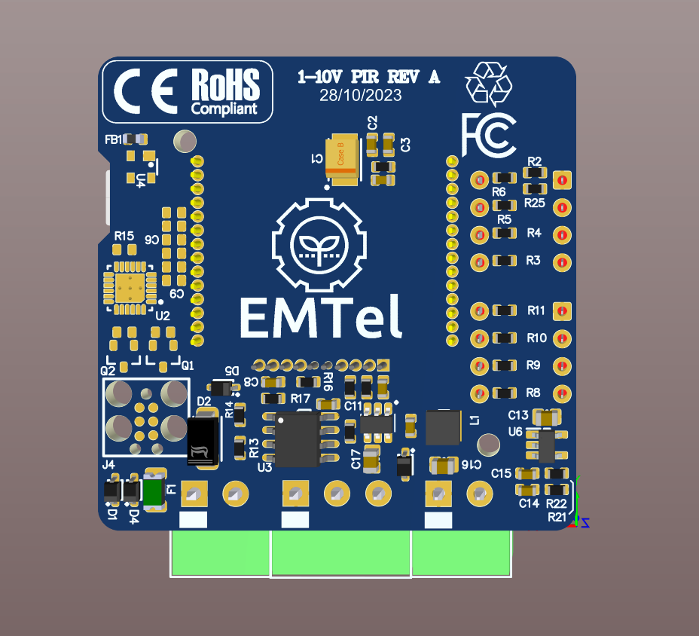
Figure 3: bottom view of production.

Connections and Dip switches

There are 2 dip switches on the board for adjusting delay and adjusting dimming.
There is one connector for LED driver, one for PIR sensor and the other one for 24V input, note that the device will power on by USB but for LED driver to work we need 24V input.
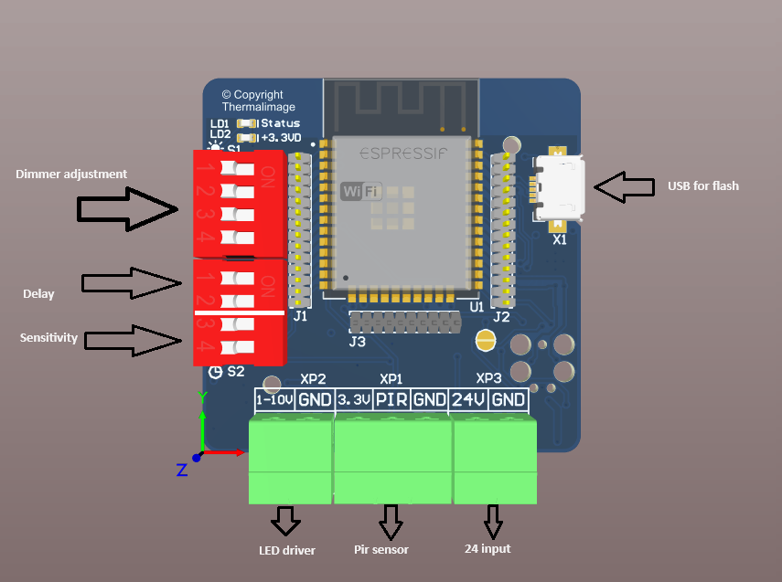
Figure 4: Connections and dip switch on the board

Flashing the device (prototype)
Current build is prototype build which does not need tag connect and can be flash directly using USB.
After connecting device to USB, a new serial port (COM port) appear on device manager, the number of appear port can be different (Fig,5 )
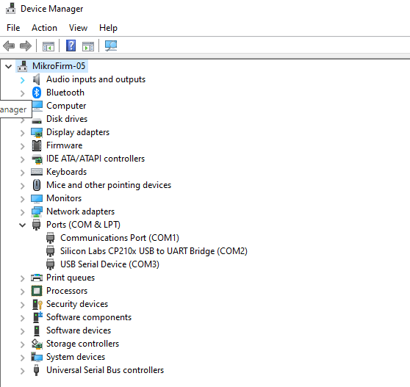
Figure 5: Silicon Labs CP210x COM2

Now open “flash_download_tool_3.9.5.exe” (from flash folder) and select ESP 32, the following screenshot.
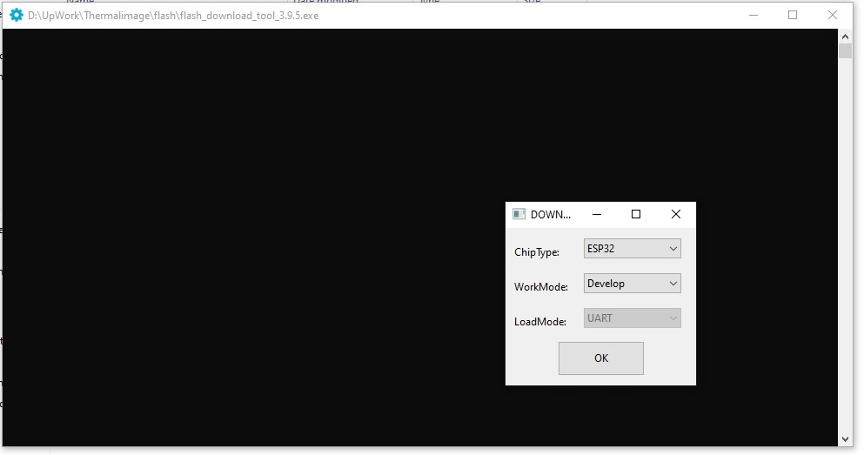

The set up as the following figure and select right com port.
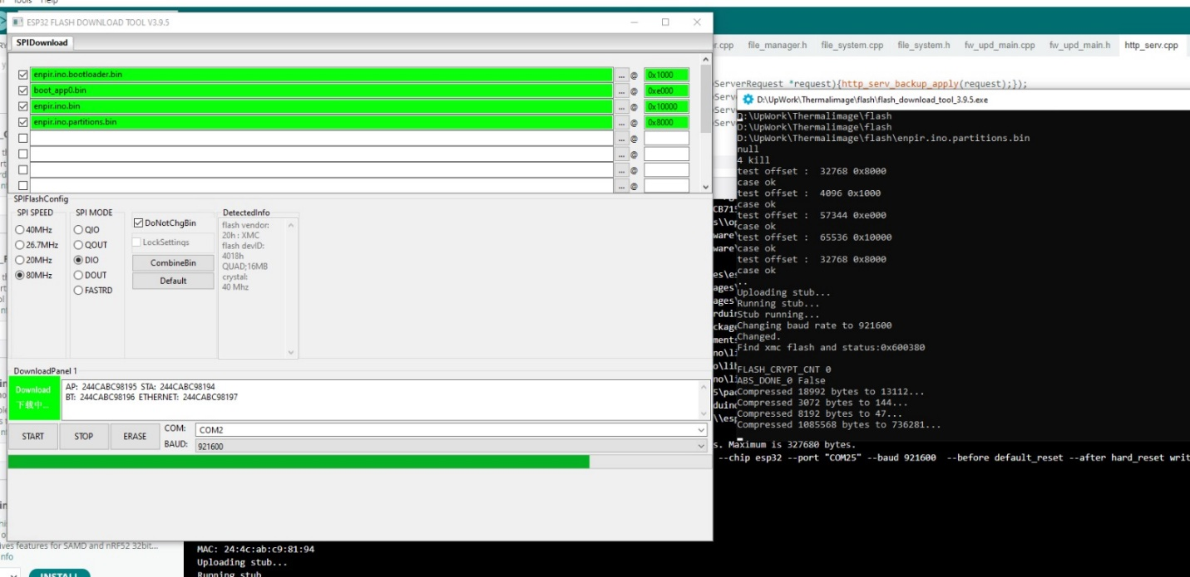
After flashing follow the these steps.
The first step is to connect to the device.
Devices advertise itself as an access point and name (SSID) is
ENPIR-<mac address>
Password: enco212345
After connection go to a browser and the address is 192.168.1.1
Enter ‘admin’ as username and ‘admin’ as password (Fig, 1).
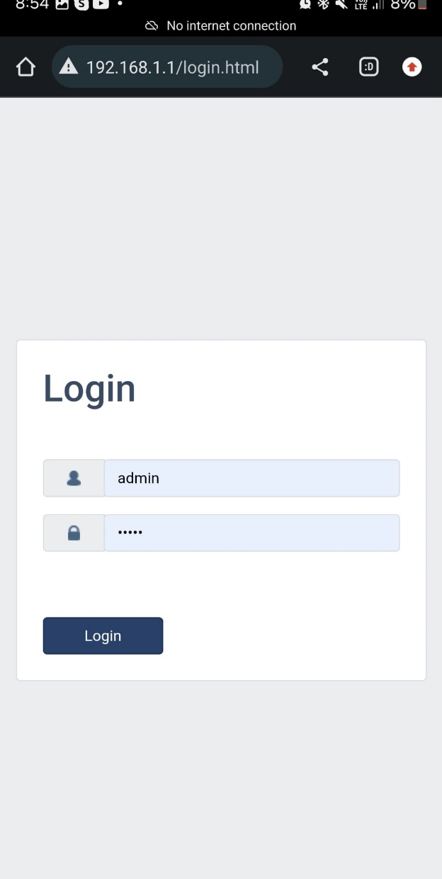
Figure 6: connect to access point and login.
Then from the hamburger button, select WIFI, enable STA mode and scan for the WIFI SSID and enter the password. After connection you will see the IP address associated to the device by DHCP (Fig,2).
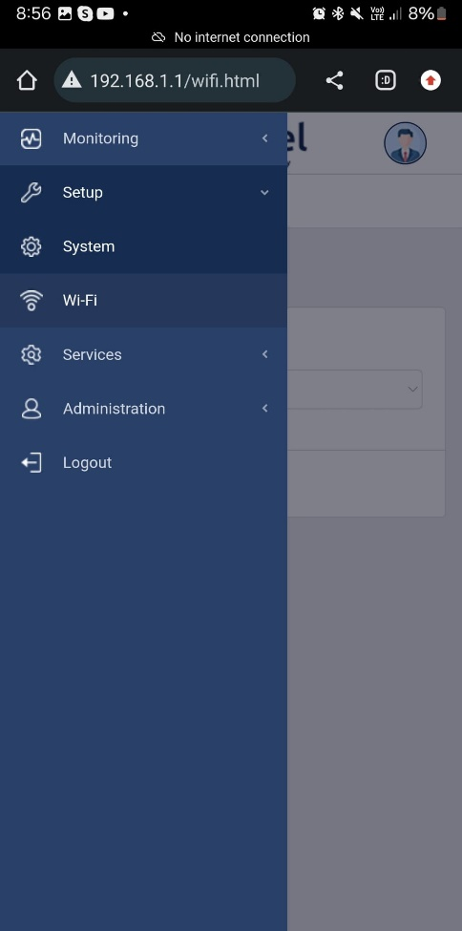 | 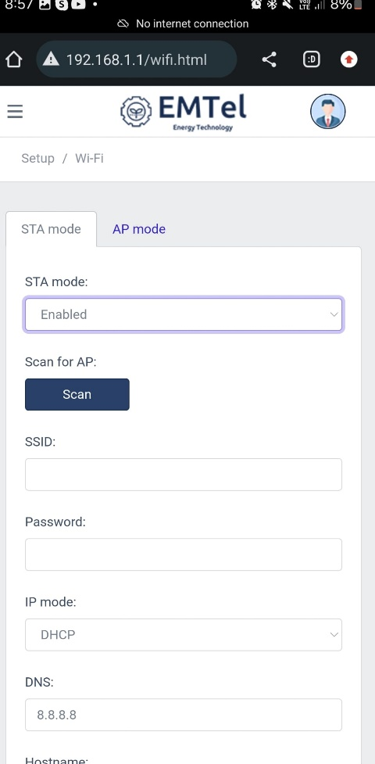 | 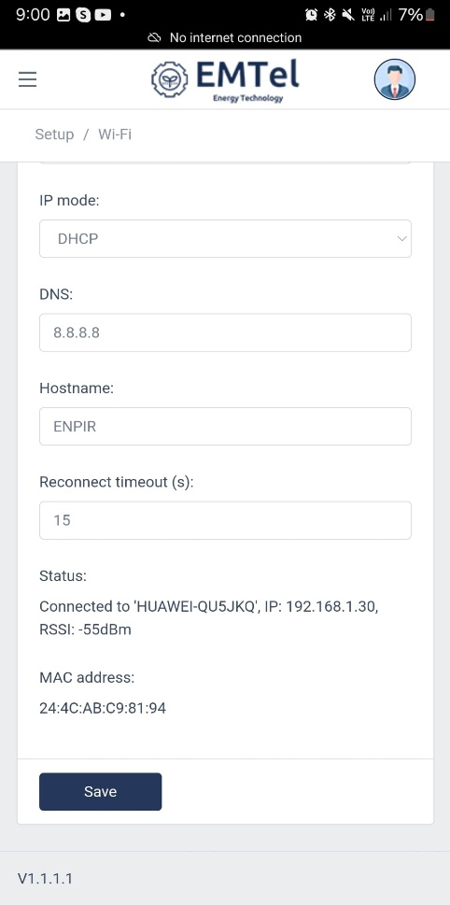

Figure 7: setup WIFI

Now the device can be accessed using this IP with a computer or a mobile on the same network.

1-10 PIR Dimming control Sensor

For setting up the 1-10, please go to setup/system and enable Display and by default it shows 25 to 100, and other values can be selected by using dip switch on the board.

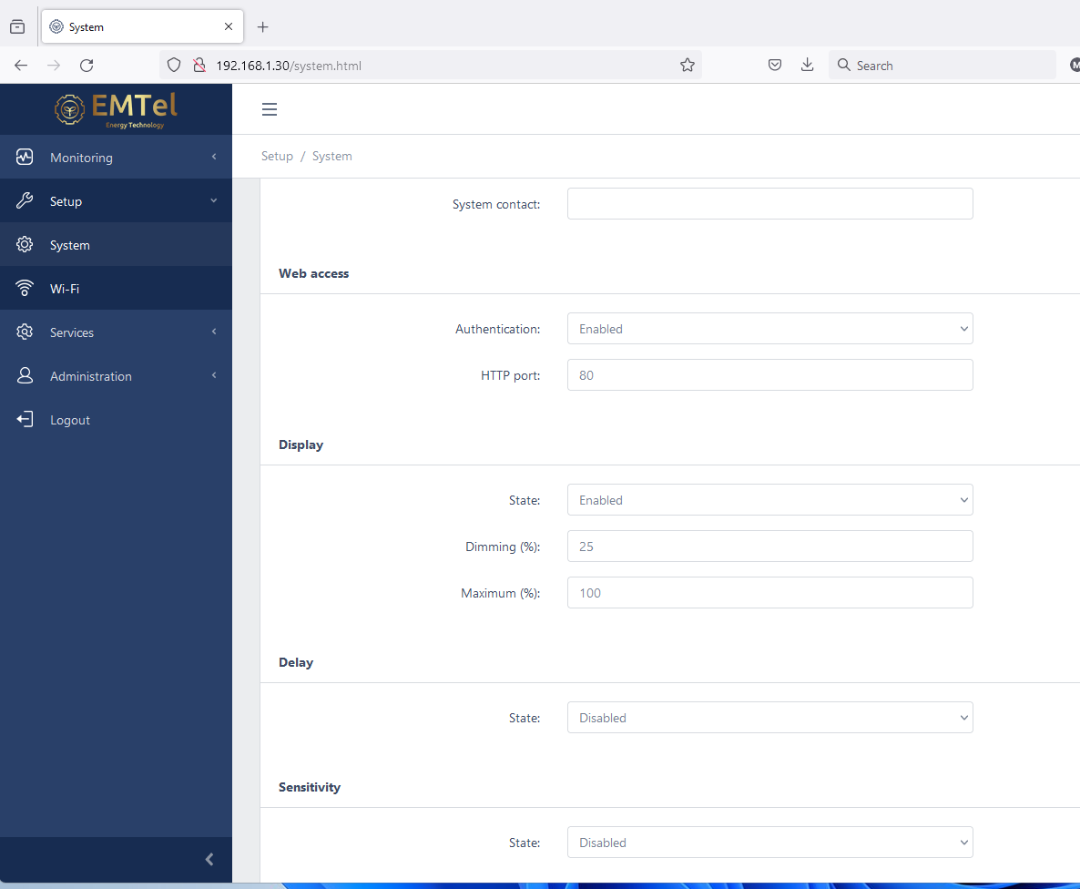

When the device triggers (PIR sensor activated) the voltage level of driver goes to the maximum that is setup in the web UI considering the position of 4-bit dip switch (refer to Fig 4).
The applied voltage value is based on the diffidence between maximum and minimum, divided by dip switch value
Example:
Maximum: 100% (10V)
Minimum: 25% (2.5V)
(S1) 4-bit dip position (1,2,3,4) 1111 (see Fig, 8)
The applied value will be 10V during activation.
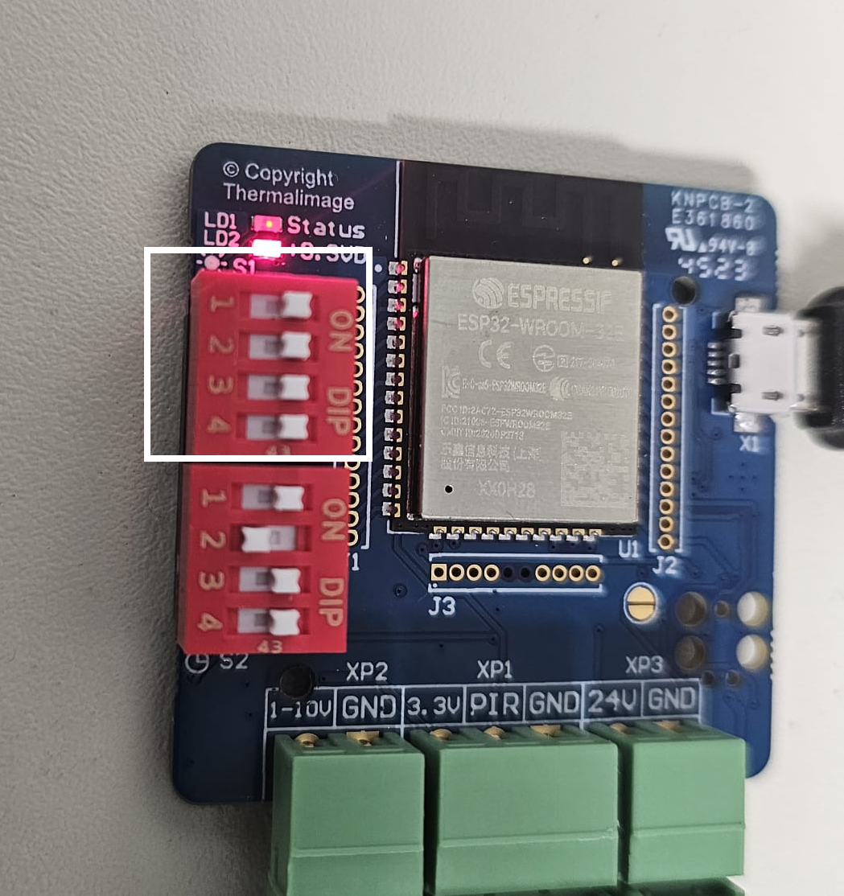
Figure 8: Position of dip switch for 1111

(S1) 4-bit dip position (1,2,3,4) 0000
The applied value will be same as minimum during activation.

S1) 4-bit dip position (1,2,3,4) XXXX (see Fig, 8)
XXXX should be turned to binary.
The applied value will be same as minimum + 1/15 (maximum – minimum)x(XXXX) during activation.

Note 1: that if the delay disabled the output of LED driver will be 0.
Note 2: The minimum dim allowed is 10% and the minimum and maximum should have at least 20% difference.

Connect the LED driver and test.

1-10 PIR delay
When the delay is enabled, after activation and deactivation timer will start.
If all delay switch is on 11 it is full delay set in the web portal and if
XX the results
(XX+1)/4 x (time set in the web portal).

